MF3 Demo User Manual

Manual Name：MF3 Demo User Manual
Manual NO ：
Version：V1.0

Total 8 pages
(Including cover)

Compose ZhangYong
Review
Countersign

Cilico Microelectronics Co., Ltd
Modifiy record
File No. | Version | Composed By / Modified By | Compose / Modify Date | Modify Reason | Major changes  （Write main Points） | Review By
 | V1.0 | ZhangYong | 2017.03.27 | None | None | ShiLiangYi
Note: When the file is prepared for the first time, write “None” on "Modify Reason" and "Major modifications columns.

Contents

1. Purpose 4
2. Applicable Scope 4
3. Install APK 4
4. Open NFC Service 4
5. Launcher App 4
6. Card Discover 5
7. Card information 5
8. Card manager 5
8.1 read 6
8.2 write 6
8.3 create 7
8.4 delete 7
9. Help 8

1 Purpose
Guide how to identify MF3 card, how to read the card data, how to write data to the card, and how to lock card.
2 Applicable scope
Use for the IOT handheld terminals which supports the NFC-enabled .
3 Install APK
First ensure that the device supports the NFC function, Then check whether the device had install this APP, if it was not installed，so install NfcManager.apk。
4 Open NFC Service
First open the “Setting” App ，Then select “more”options of “Wireless & networks”group,，Last select “NFC”options，and open NFC service，and open “Tag reading & writing”。
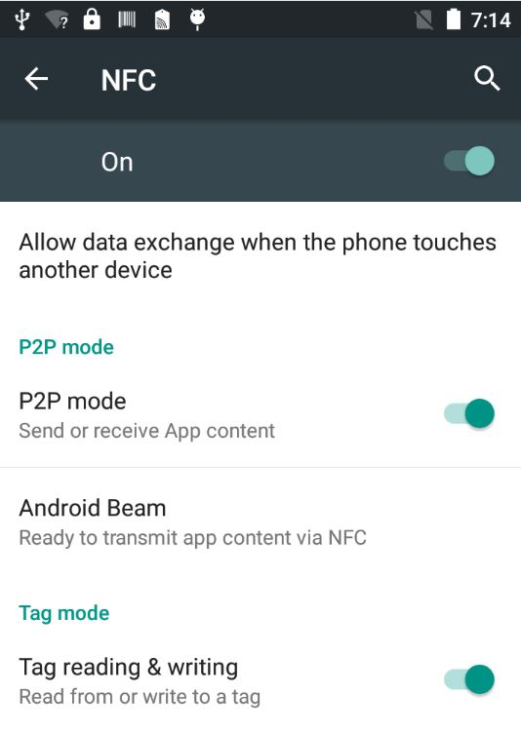

5 Launcher APP
Click the NFC APP Icon to launcher it. 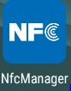
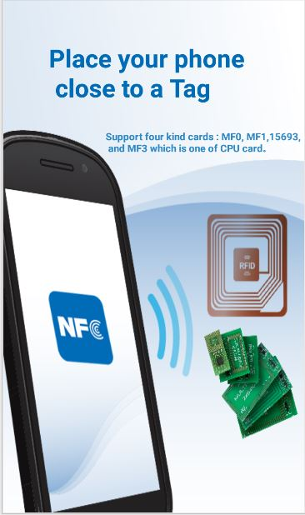
6 Card Discover
Put the MF3 type card into the back of the handheld terminal. After hearing the sound of "toot" , the application interface will automatically pop up, so keep the card not to be moved。
7 Card Infomation
After the card is successfully identified, the basic information of card is parsed and displayed in the top area
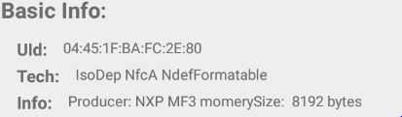
8 Card Manager
8.1 Read
First select the program ID to read, then select the file ID, and finally click the "read" button, the results will be displayed in the bottom information area,with including AppKey, FileSettings, and data
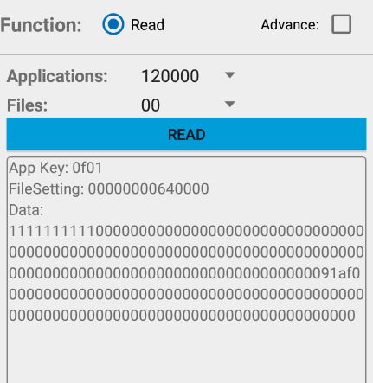
8.2 Write
8.2.1 Show Write Function
First select the "Advanced ", then select "write" radio button, and you can see the interface of write function
8.2.2 Write Data
First select the App ID, then select the file ID, and then input the maximum 15 bytes of hexadecimal data, and finally click "write", success or failure will be shown below.
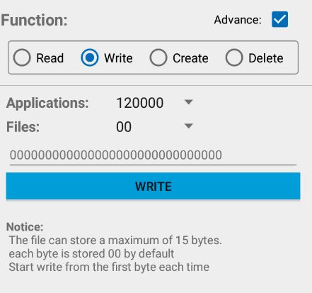
8.3 Create
8.3.1 Show Create Function
First select the "Advanced ", then select "Create" radio button, and you can see the interface of write function
8.3.2 Create Application
First input the 3-byte hexadecimal App ID, and then click the "Create" button, success or failure will be shown below.
8.3.3 Create File
First select the App ID, then input the 1-byte hexadecimal File ID, and then click the "Create" button, success or failure will be shown below.
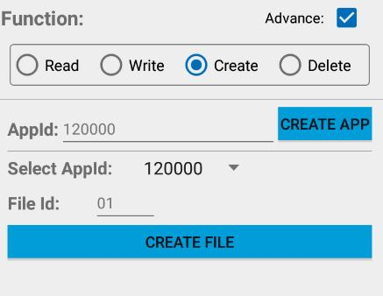
8.4 Delete
8.3.1 Show Delete Function
First select the "Advanced ", then select "Delete" radio button, and you can see the interface of write function
8.3.2 Delete Application
First to select the App ID, and then click on the "delete App" button, success or failure will be shown below.
8.3.2 Delete File
First to select the App ID, and then select the File ID，and finally click on the "delete File" button, success or failure will be shown below.
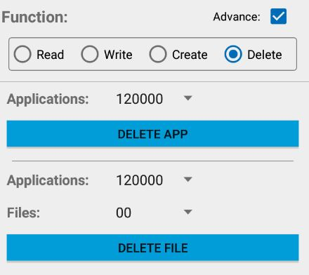
9 Help
Click the upper right corner of the icon, enter the help interface, which describes the MF3 card basic information, as well as some operating instructions.

